**2023 Sampson County Parks and Recreation**

Tackle Football

Local Guidelines and Rules

**National Federation High School** rules will be used with the exceptions listed below:

**1:00 DIVISIONS:**

Varsity: Ages 10-12 years

**2:00 AGE REQUIREMENTS:**

2:01 Varsity Division

**Minimum Age**: Ten (10th) years old - players must reach their tenth (10th) birthday on or before August 1 of the **current school year**.

**Maximum Age:** Twelve (12) years old - players cannot reach their thirteenth (13th) birthday on or before August 1 of the **current school year.**

**3:00 FIELD SIZE:**

3:01 The field will be (100) yards in length. Kickoffs will be from the 40 yd. line. The receiving team will be allowed to line up on the 50 yd. line.

**4:00 WEIGHT REQUIREMENTS:**

4:01 Varsity Division: All players must weigh a minimum of 60 lbs. Any players that weights over **150 lbs.** (body weight) will be always marked with a stripe of tape on their helmet. These players may only line up on the Offensive or Defensive line inside the tackle box. They must be in a 3 or 4-point stance when the ball is snapped. There is a maximum of 5 striped players on the field at a time. 9-year-old must be a minimum of 90 pounds to be eligible to play.

These players are not allowed to advance the football. If they gain control, the ball is

Immediately dead.

**Penalty:**

*1st Offense – Team Warning*

*After 1st – 5 yard Delay of Game*

**All Players will be weighted by SCPR before the first game.**

**Note* A coach can request a weigh-in for their player(s) if he/she feels that the child is under the weight restriction (30 min. before game). A coach that wishes to weigh an opposing team’s player(s), has until kickoff. Once the game starts, weigh-in requests will not be accepted.**

**5:00 GAMES**

5:01 Games will consist of four 12-minute quarters.

5:02 The clock will stop after the point after attempt (PAT). The clock will restart on the kick-off and run continuously for the remainder of the game (except for the last (2) two minutes of the 4th quarter.) During the last two minutes of the 4th quarter, the clock will run in accordance with the rules governing high school play. Half-time will consist of a five (5) minute interval; the half time interval may be shortened due to game conditions. Kicking a PAT will be worth 2 points no rushing the kicker will be allowed (All defensive players should take a knee).

5:04 **OFFENSE**: Any legal offensive formation may be used.

**DEFENSE**:

1. **Only 5 defensive players on the line of scrimmage – all others are 5 yards back**.
2. Inside the 5-yard line, “a goal line defense” is allowed.
3. Defensive players may NOT line up head-to-head of the center. He may line up in the gap or on the shoulder of the center.

5:05 Each team will be allowed three (3) time-outs per half. Thirty (30) seconds each.

5:06 There are two (2) types of conference allowed:

1. Coach may go on the field in the huddle during time-outs. He may carry a book, cards, or clipboard. If the coach delays the game by not leaving the field promptly at the conclusion of the time-out, the officials may deny the coach the opportunity to come onto the field for the remainder of the game.
2. One (1) or more players and one (1) or more coaches directly in front of the team box within five (5) yards of the sideline

5:07 A minimum of nine (9) players must be present for a team to play. A team will forfeit the game if it does not have at least nine (9) players on the field within ten (10) minutes after the scheduled starting time for the first game of the day. All other games will begin (or be forfeited) at the scheduled starting time.

5:08If a team is ahead by 21 points, score will not be displayed, and a continuous clock will be used until the score is less than 21 points.

5:09 Overtime period: There will be no overtime.

5:10 Extra points: Run = 1 Point; Pass = 2 Points. Kicking = 2 points (NO RUSH ALL PLAYERS SHOULD TAKE A KNEE)

5:11 **Punting:** Teams have the option to elect to “punt” or go for it on fourth down. Putting will be 25 yards from the spot of the ball. If a team goes for it on fourth down and does not reach the line to gait the opposing team will take over from the final spot of the 4th down play. Inside of the opponents 40 Yard line the put will be half the distance to the goal.

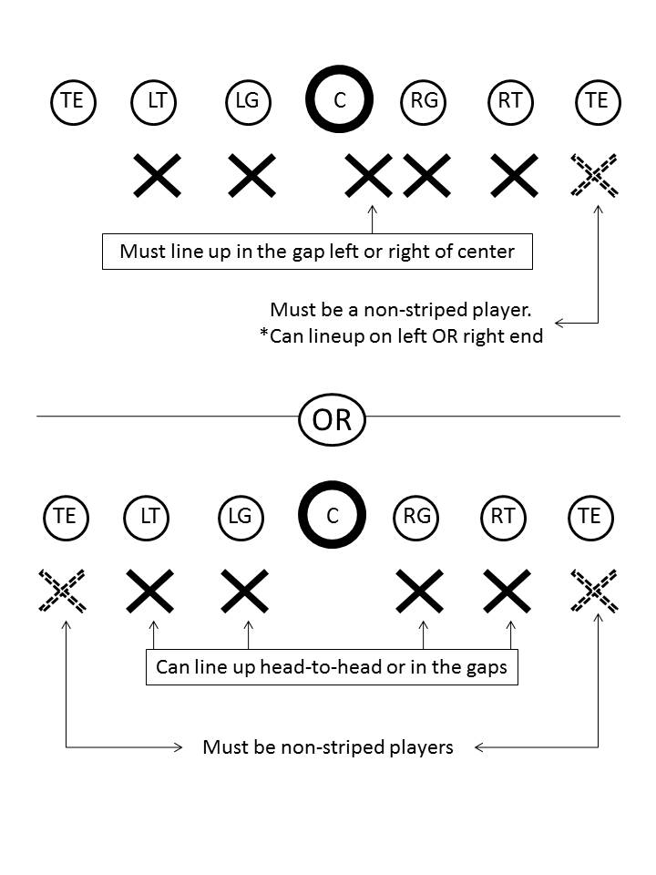

**6:00 EQUIPMENT:**

6:01 All equipment will be purchased by the Recreation Department. No coach or parent has the authority to obligate the team or Recreation Department financially without the consent of the parties involved; otherwise, the expenditure will become the responsibility of the individual.

6:02 Individual equipment shall consist of a helmet (with chin strap), shoulder pads, game jersey, mouthpiece, and pants with pads. Each player will furnish their own protective cup, socks, and shoes (which must be tennis shoes or rubber molded cleats). Screw-in, metal, or steel cleats are not allowed**.**

6:03 **Players must have three (3) non-contact practices before equipment will be issued. Equipment will be issued at a team scheduled time.**

6:04 Mouth pieces and chin straps are mandatory.

6:05 All equipment worn by players must conform to local or official football rules.

6:06 Footballs:

1. Varsity Division: Ages 10-12 years TDY

**7:00 PARTICIPATION RULE:**

7:01 Each player must play a minimum but not limited to 5 plays each half.

Coaches are not obligated to play an individual the minimum time under the following conditions:

1. Player late for start of match or a no-show.

2. Player with unexcused absence from practice in the week before the match.

3. Player who has been a discipline problem.

4. Injured player who could have played the minimum time if uninjured.

A coach who suspends a player, according to rule, must get it approved by SCPR Staff prior to the game and notify the opposing coach and parents, prior to the start of the match.

**8:00 PRACTICE:**

8:01 Coaches are expected to closely observe their players to be certain that they do not become overly fatigued.

8:02 Practices will be limited to 1 hour and 30 minutes in length.

8:03 Practices must be over by 8:30 p.m.

8:04 Teams cannot practice more than two times per week during a game week and three times per week during a non-game week. Only 2 full contact/pads (games/practices) allowed per week. EX. 1 game and 1 full padded practice, 2 full padded practice and no games.

8:05 All Practices must be scheduled through the Recreation Department.

**9:00 POSTPONED GAMES/INCLEMENT WEATHER**

9:01 Weather decisions will not be made until after 3PM. 910-299-0924

If games or practices are cancelled, the Recreation Department will contact the coaches and they are then responsible for notifying their players.

9:02 Prior to the start of the game, the field supervisor or Recreation Department staff on duty will have sole authority to postpone or play the game.

**10:00 COACHES**

10:01 Only 3 coaches/trainer/manager may be allowed on the sideline. All other persons must stay behind the restraining fence. Head coach will be responsible for keeping unauthorized persons out of marked bench area.

**Penalty*:*** *Ten (10) yards*

10:02 Coaches may request time-outs from the sideline.

10:03 No coach will be allowed on the field except when time out is called and with the official’s permission.

**Varsity-**  One coach will be allowed on the field with his/her team for calling a play this coach is only permitted to meet with one player while on the field. The coach may not go pass the numbers painted on the field. They must return to the sideline before the ball is snapped.

**Penalty*:***

*1st Offense – Ten (10) yards*

*2nd Offense – Removal from the game as an on-field coach*

**11:00 SPORTSMANSHIP:**

11:01 No alcoholic beverages are allowed on school or recreation property. This includes athletic fields. This is a **STATE LAW.** If necessary, proper legal action will be taken to enforce this rule. **NO TOBACCO PRODUCTS - SMOKING, CHEWING, DIPPING, ETC...ARE ALLOWED ON THE PRACTICE OR PLAYING FIELD.**

11:02 A coach, player, or spectator with the presence of alcohol on their breath will be asked to leave the recreation area.

11:03 Unsportsmanlike conduct **WILL NOT** be tolerated before, during, or after a game or practice. Any coach, player, volunteer, or spectator who is ejected/removed from a practice or game will be suspended.Suspension length will vary depending upon the severity of the infraction. Persons guilty of a second offense causing their ejection/removal within the recreation year shall be suspended for the remainder of the recreational year.

11:04 When a coach, player, volunteer, or spectator is ejected/removed from a game or practice, they shall leave the facility/grounds immediately and take no further part. Any coach or player or spectator who is ejected from a game will be suspended for the remainder of that game and the next scheduled game. The suspension could be longer depending upon the severity of the infraction. Persons guilty of a second offense causing their ejection during the same calendar year shall be suspended for minimum of 365 days or longer depending on the infraction.

11:05 All Coaches and Players will shake hands after each game. (Minium 1 game suspension)